Room 1: AI and Your Future at Work (Taurai Nyaruwata)
Focus: How to stay relevant, useful, and ahead in a changing world
Topics may include: what AI is changing in the workplace; what skills will still matter; how to use AI wisely; how students and young professionals can prepare now.

As a technology researcher at a leading consultancy, Taurai Nyaruwata investigates how people and businesses can adapt to the evolving work environment. With over 20 years of experience driving digital transformation, he now empowers the next generation to navigate the AI era, combining deep industry expertise with practical, forward-thinking strategies.
Room 2: Make the Interview and Ace the Interview (Fikile Mavangwa)
Focus: How to apply with a CV, prepare for interviews, answer well, and stand out with confidence
Topics may include: CV writing, common interview mistakes; how to answer difficult questions; confidence and preparation; in-person and virtual interview tips; what recruiters and managers notice.

With 7 years of HR experience, Fikile Mavangwa has recruited talent across all levels, from internships to senior management and across a variety of roles and industries. Holding a Bachelor of Psychology (Cum Laude), she is passionate about helping young professionals understand what employers look for and prepare confidently for interviews.
Room 3: Build Your Brand and Reputation (Raksha Naidoo)
Focus: How to be known for credibility, character, and excellence
Topics may include: personal brand in the workplace; first impressions; consistency and professionalism; networking and visibility; online presence and reputation.

Room 4: Managing Your Mental Health and Emotional Wellbeing (Angela Senosha & Gillian Donà)
Focus: How to stay mentally and emotionally well while navigating study, work, pressure, and transition
Topics may include: managing stress and anxiety; dealing with pressure, comparison, and burnout; building healthy routines and boundaries; resilience in seasons of uncertainty or disappointment; knowing when to seek support and how to care for your emotional wellbeing in a sustainable way.
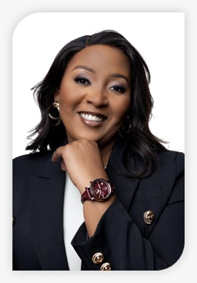
Angela is a multi-award-winning HR Professional and the Founder & CEO of Positive Switch, she is recognised for delivering strategic, tech-enabled human capital solutions. Named among Africa’s Top 40 Under 40, she facilitates HR due diligence, organisational optimisation, and sustainable business growth solutions through innovative, future-focused people strategies.

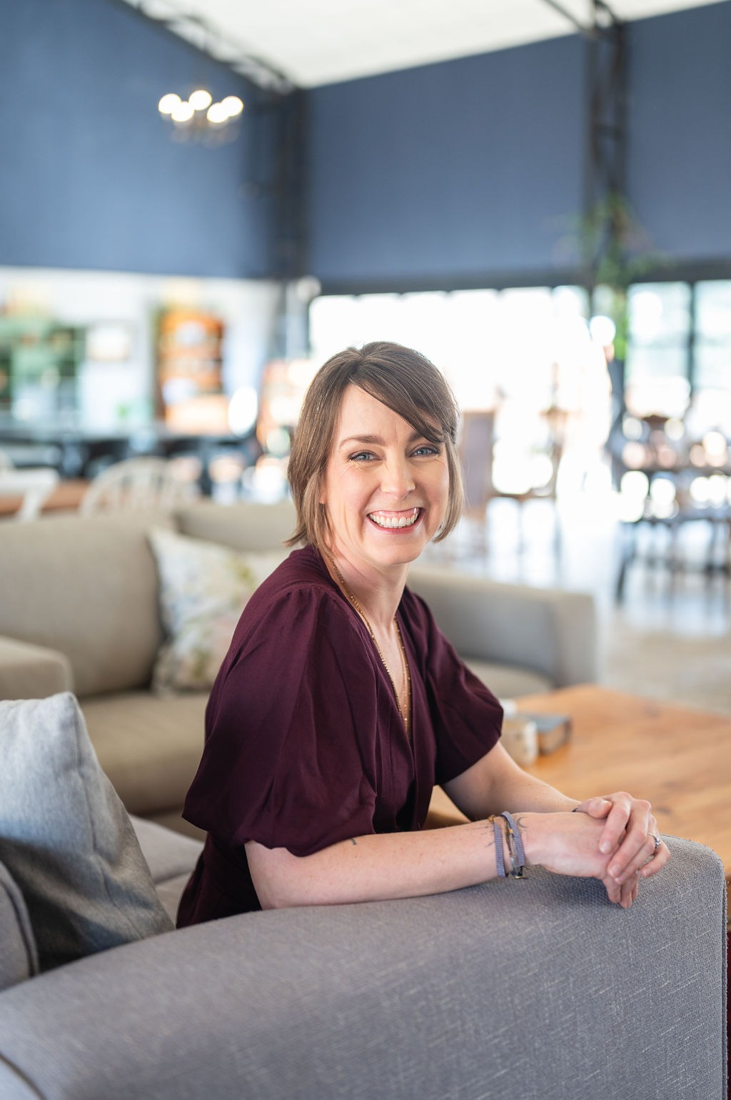
Registered Industrial Psychologist, Career Coach, and counsellor Gillian Donà believes being well at work combines clear career direction with the capacity to withstand hard things. With 20 years of experience, she equips young professionals with practical psychological tools to master stress, build confidence, and sustain resilient career growth.
Room 5: How to Grow, Get Noticed and Get Promoted (Cohen Appanah)
Focus: What actually helps people move forward at work
Topics may include: ownership and initiative; reliability and excellence; communication with leaders; leadership before title; what makes someone promotable.

Passionate about high-performance, Cohen Appanah is an award-winning leader and global management professional who knows what it takes to stand out. He teaches ambitious individuals how to get noticed, build strategic relationships, find mentors and sponsors, create a strong track record, and position themselves for promotion, career growth and greater leadership opportunities.

Room 6: From Job to Business (Melissa Chisoko)
Focus: Moving beyond corporate into business with wisdom
Topics may include: when to consider the move; what readiness looks like; risk, side hustles, and timing; lessons from founders; mistakes to avoid when starting out.
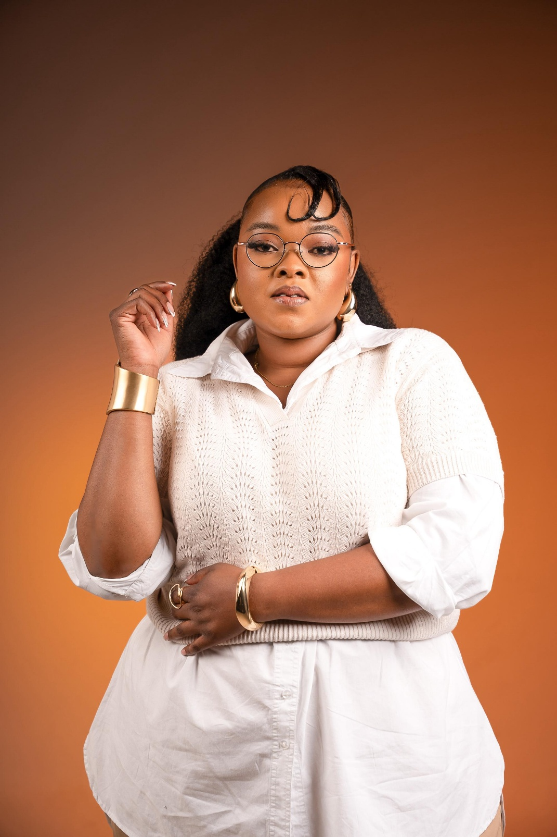
Melissa Chisoko is a qualified Financial Accountant, multi-award-winning entrepreneur, and former corporate professional who transitioned from a 9–5 career into full-time entrepreneurship. She is the founder of Mazh Babies and Classi Beauty Studio. Her work has been featured in British Vogue and Glamour UK, and Mazh Babies is stocked in Chelino stores nationwide. She is passionate about helping young professionals build purpose-driven businesses and confidently navigate the transition from employment to entrepreneurship.

